Objective Questions:
Q1.In analyzing the hospital dataset with Power BI, ensure data cleaning to address inconsistencies and missing values before further analysis.
As part of our initial data exploration in Power BI, we prioritized data cleaning to ensure consistency and reliability across our analysis. Using the Power Query Editor, we navigated to the View tab and enabled Column Quality, which allowed us to visually assess the presence of null values and inconsistencies across the dataset.
During this step, we identified that the patient_sat_score column had a significant number of missing values. To address this without compromising data integrity, we created a new calculated column, patient_corrected_sat_score, which intelligently fills null values with the average satisfaction score of all patients.
The DAX formula we used for this correction was:

patient_corrected_sat_score=ROUND(if(ISBLANK('HospitalER(1)'[patient_sat_score]),AVERAGE('HospitalER(1)'[patient_sat_score]),'HospitalER(1)'[patient_sat_score]),0)

Q2.Assess the Average Waiting Time: Analyse the patient wait times to identify the average duration a patient spends before receiving care.
- To better understand operational efficiency, we analyzed the average waiting time experienced by patients before receiving care. This metric is critical for identifying service bottlenecks and improving patient satisfaction.
- Formula used: Average_waiting_time = AVERAGE('Hospital ER (1)'[patient_waittime])
Gives 35.26 min
- Additionally, we used a card visual to represent this KPI by simply dragging and dropping the patient_waittime field into the visual and setting the aggregation to Average. This allowed for a clean and immediate snapshot of the hospital's responsiveness, enabling stakeholders to monitor this metric in real time.
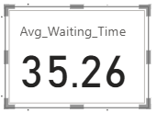

Q3. Visits by Department Referral: Calculate the total number of visits to each department based on referrals to understand which departments are most frequently visited.

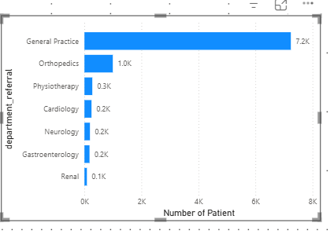
Insights:
- The most frequently visited department is General Practice with over 7,200 patient visits.
- Orthopedics also handle a large number of patients’s population of 995.
- The least visited department is Renal, with only 86 patient visits.
- The chart clearly indicates that General Practice handles a majority of hospital footfall, highlighting it as a critical department for staffing and resource allocation.
Q4.Patient Visits by Age Group: Segregate patient visits according to different age groups to see which demographics utilize healthcare services the most.
Approach:
To understand the distribution of healthcare usage across various age demographics by categorizing patients into age groups.
Age | Age group
0 to 12 | Child
13 to 19 | Teenager
20 to 39 | Adult
40 to 59 | Middle Aged
Greater than 60 | Senior Citizen

After that we will use DAX formula in a measure:
Formula:
Age Group = SWITCH(true(),'Hospital ER (1)'[patient_age]>=0&&'Hospital ER (1)'[patient_age]<=12,"Child",'Hospital ER (1)'[patient_age]>12&&'Hospital ER (1)'[patient_age]<=19,"Teenager",'Hospital ER (1)'[patient_age]>19&&'Hospital ER (1)'[patient_age]<=39,"Adult",'Hospital ER (1)'[patient_age]>39&&'Hospital ER (1)'[patient_age]<=59,"Middle Aged",'Hospital ER (1)'[patient_age]>59,"Senior ")
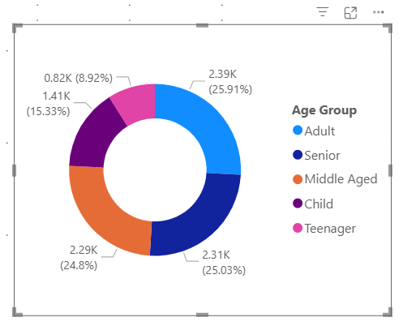
Insights:
- The Adult age group constitutes the largest patient segment.
- This is followed by Senior Citizens, indicating a high demand for adult and geriatric care services.
- The insights can guide targeted outreach programs, preventive care, and age-specific medical services.
Q5. Were there any Null values in the data? What would be the best way to handle these Null values and which approach have you opted for?
- We began by examining the dataset in the Power Query Editor, enabling Column Quality from the View tab. This feature provided a clear breakdown of valid, error, and null values in each column.
- We found that the patient_sat_score column contained a considerable number of null values. Since this field directly affects patient satisfaction insights, we opted for a data imputation strategy rather than discarding records.
- To preserve the overall satisfaction trend while filling the missing data, we created a new calculated column using the following DAX formula:
- patient_corrected_sat_score = if(ISBLANK('Hospital ER (1)'[patient_sat_score]),AVERAGE('Hospital ER (1)'[patient_sat_score]),'Hospital ER (1)'[patient_sat_score])
- This formula replaces null values with the overall average satisfaction score, ensuring the imputed values remain unbiased and representative of the dataset as a whole.

Q6. Is there any relation between the number of visits and the Gender of the patients?
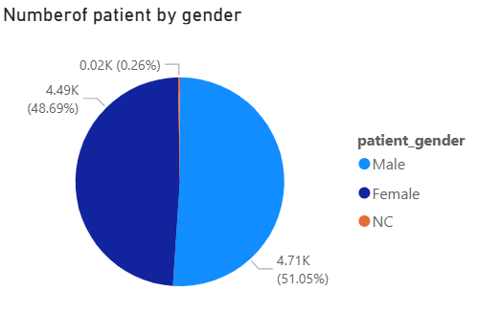
Insights:
- Male patients slightly outnumber female patients in terms of hospital visits.
- The difference is marginal and does not indicate any significant gender-based disparity in healthcare usage.
- “The ‘Not Classified’ category accounts for a small portion of the patient population (0.3%). While this may include data entry gaps, it may also reflect patients who identify as non-binary or prefer not to disclose their gender

Q7. Average Satisfaction by Demographics: Determine the relationship between patient satisfaction scores, their age groups, and racial backgrounds to pinpoint areas for improvement in patient experience.
Fields used:
- Age Group on X-axis
- patient_corrected_sat_score in Values (aggregation: Average)
- patient_race in Legend
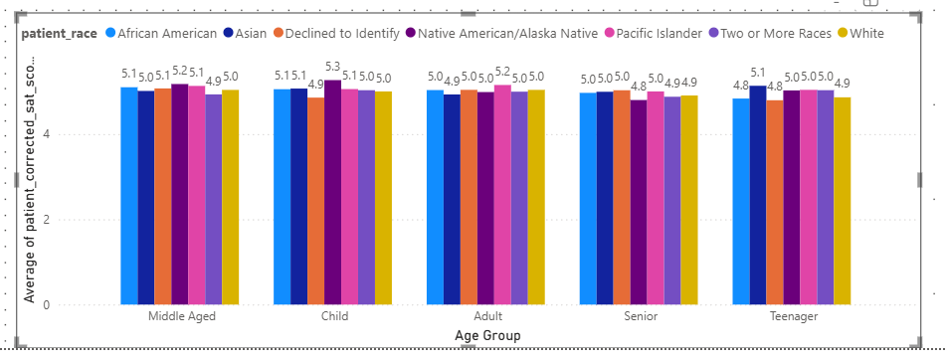
Insights:
- Satisfaction levels remain consistent across age and race segments, with minor variance.
- Children (Native American/Alaska Native) show the highest satisfaction at 5.3.
- Slightly lower satisfaction (~4.8–4.9) is seen among Teenagers and Seniors across multiple races

Q8. The hospital's managing director seeks to evaluate the revenue of each department to understand how much revenue is generated by each.
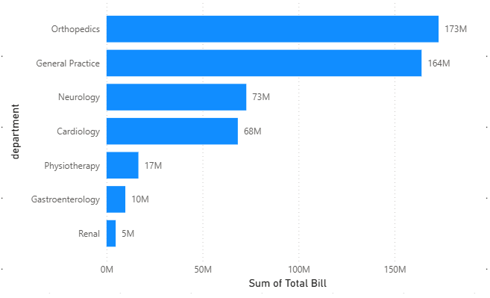
Insights:
1.₹172.9M in billing makes Orthopedics the top revenue contributor, likely due to:
  - High treatment cost procedures
  - Frequent follow-up visits or chronic condition care
2. Despite being second in revenue (₹164M), General Practice serves the most patients (7,240+ as per data).
- This suggests a low-to-moderate average billing per patient, driven by:
  - High footfall
  - Routine consultations
  - Lower appointment fees
3. Neurology (₹72.8M) and Cardiology (₹68.4M) contribute significantly despite relatively lower visit counts (193 and 248 respectively).
- Indicates high-cost treatments per patient, potentially reflecting advanced diagnostics, procedures, or long treatment durations.
4. Physiotherapy and Gastroenterology generate minimal revenue
- Physiotherapy: ₹16.6M
- Gastroenterology: ₹9.7M
5. Renal Department: Lowest Revenue Generator
- ₹4.75M total — the lowest billing contributor.
- Could indicate:
  - Very niche/specialized care
  - Low patient volume or referral rates
  - Underutilization of available resources
Q9. Which department is charging the highest appointment fees in general? Use an aggregation DAX function to solve this question.
Dax formula
Highest appointment fees across all departments = LOOKUPVALUE('Hospital ER (1)'[department_referral],Doc_patients[Appointment Fees],max(Doc_patients[Appointment Fees]))
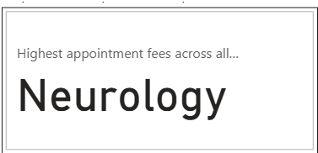

- Insights:
The analysis revealed that the Neurology department charges the highest appointment fee among all departments
Q10 Create a tabular visualization in the Report view which consists of Month-wise total visits in the hospital. Add a third column in the table that consists of the previous month’s total visits for each month’s row. Also, include a column that states whether the visits in a month are greater than that of the previous month's visits.
- Dax formula for visit_trend=
Visit_Trend = if('Hospital ER (2)'[patient_count]>'Hospital ER (2)'[prev_month_patient_count],"Growth","Decline")

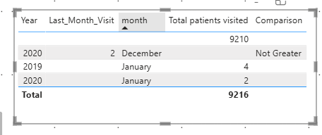
Q11. Using ‘Calculate’ and a row iteration DAX function calculate the total number of patients who have visited Dr. Smith.
Dax formula total patients of Dr.smith = CALCULATE(COUNT('Hospital ER (1)'[patient_id]),'Doc_patients'[Doctor Name]="Dr. Smith")
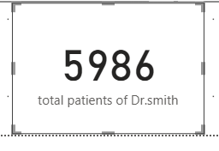
Insights:
- A high number of patients visiting Dr. Smith may indicate strong patient trust, a high degree of popularity, or specialization in high-demand, general treatments.
- Since Dr. Smith is from General Practice, this suggests broad accessibility and a wider patient base, as general practitioners often act as the first point of contact for most health concerns.
- This trend may highlight the importance of general medicine in overall hospital service delivery and the need to ensure adequate support for high-volume general practitioners.
Q12.Calculate the average age of the patients who visit the Orthopedics department. Will the approach used to calculate this metric be different if the requirement had been all departments’ average age?
Dax formula
avergae of age who visited Orthopedics department = CALCULATE(AVERAGE('Hospital ER (1)'[patient_age]),'Hospital ER (1)'[department_referral]="Orthopedics")

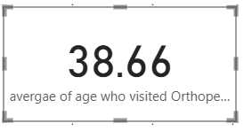
Overall age average
Dax formula
overall average age = AVERAGE('Hospital ER (1)'[patient_age])
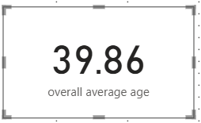
Insights:
- The average age of patients in the Orthopedics department is higher than the overall hospital average, confirming that Orthopedics primarily serves an older patient group.
- This directly reflects the department’s focus on age-related issues such as joint replacements, arthritis, and fracture management.
- The higher average age profile indicates that Orthopedics requires specialized care pathways tailored to elderly patients, including pre- and post-operative support and rehabilitation.
Q13.Were there any data format issues in the data, and if there were/are how you handle them?
- Yes, there were data format issues in the patient_sat_scores column and the date column of the “Hospital Info” table.
- The date column was initially in text format, so we converted it to a proper date format to ensure it could be used accurately in analysis.
- For the patient_sat_scores column:
- We noticed blank spaces that could affect calculations and analysis.
- The column was originally in text format, so we first converted it to a numeric data type.
- We then replaced the blank (null) values with the mean value of the column. This approach helped maintain consistency in the data and prevented any potential bias in future analyses.
Q14.When we add a column in Power Query what’s the code that comes in M language in the formula bar? What do you know about M-query?

- When we add a new column in Power Query (for example, using "Add Column" → "Custom Column"), the formula bar shows a line of M code similar to:
- = Table.AddColumn(PreviousStepName, "NewColumnName", each <expression>)
Here:
- Table.AddColumn is the M function used to create a new column.
- PreviousStepName refers to the previous step or table in the query.
- "NewColumnName" is the name of the new column we are creating.
- each <expression> defines the logic for the new column (e.g., a calculation or a conditional expression).

What do we know about M-query?
- M-query (also known simply as M language) is the formula language used in Power Query.
- It is a case-sensitive, functional language designed specifically for data transformation and preparation tasks.
- M allows us to perform various data shaping operations such as filtering, grouping, merging, adding columns, and more.
- Each transformation step in Power Query is recorded as a separate line of M code, making the process transparent and reproducible.
- We can edit or write M code directly in the Advanced Editor to customize or fine-tune our queries beyond what the standard user interface provides.
15. Identify the top 5 doctors who generated the most revenue but had the fewest patients. (SQL)
select doctor_name, sum(total_bill) as revenue ,count(distinct patient_id) as number_of_patients from doctor_patients_data
group by 1 order by revenue desc ,number_of_patients asc limit 5;
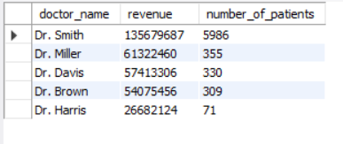
Insights:
- We observed that Dr. Smith generated the highest revenue while treating fewer patients, suggesting a focus on high-value treatments or procedures.
- Dr. Miller followed closely as the second highest revenue generator.
- This analysis helps us identify top-performing doctors contributing significantly to the hospital’s revenue despite a smaller patient load.
Q16.Find the department where the average waiting time has decreased over three consecutive months. (SQL)

Query:
with cte as(
select department_referral as department,mid(date,04,02) as month,avg(patient_waittime) as avg_waittime from hospital_data group by 1,2 )
,cte1 as(
select *,lag(avg_waittime,1)over(partition by department order by month asc) as prev_waittime,
lag(avg_waittime,2)over(partition by department order by month asc) as prev_prev_waittime from cte)
,cte2 as(
select *,case when avg_waittime>prev_waittime and prev_waittime>prev_prev_waittime then "yes" else "no"
end as decision from cte1)
select * from cte2 where decision="yes";
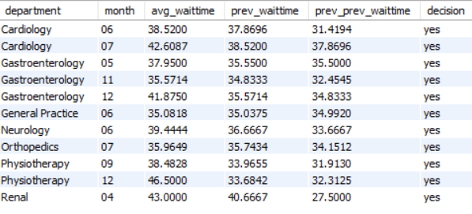
Insights:
- Only a few departments showed a consistent month-over-month decrease in waiting time for three months.
- In the identified departments, waiting times dropped steadily, suggesting operational improvements or reduced patient load.
- The decrease indicates that patients experienced progressively shorter wait periods during the selected months.
Q17.Determine the ratio of male to female patients for each doctor and rank the doctors based on this ratio. (SQL)
with doctor_patients as(
select doctor_id,sum(case when patient_gender='m' then 1 else 0 end)/sum(case when patient_gender='f' then 1 else 0 end) as ratio from
doctor_patients_data a join hospital_data b on a.patient_id=b.patient_id
group by 1)
select *,dense_rank()over(order by ratio desc) as `rank` from doctor_patients;
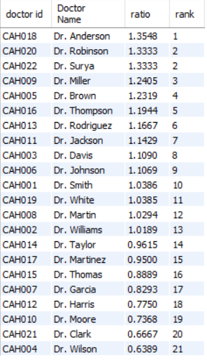

Insights:
- Some doctors have a significantly higher ratio of male to female patients, indicating a skewed patient demographic.
- Other doctors have a more balanced or even female-majority patient base, reflecting different treatment types or referral patterns.
- The ranking clearly shows that certain doctors consistently has more male patients relative to female patients.
Q18. Calculate the average satisfaction score of patients for each doctor based on their visits. (SQL)
SELECT dp. Doctor_ID,dp. Doctor_Name,
ROUND (AVG(he.patient_sat_score), 2) AS avg_satisfaction FROM doctor_patients_data dp JOIN hospital_data he ON dp.patient_id = he.patient_id
WHERE he.patient_sat_score IS NOT NULL GROUP BY 1,2;
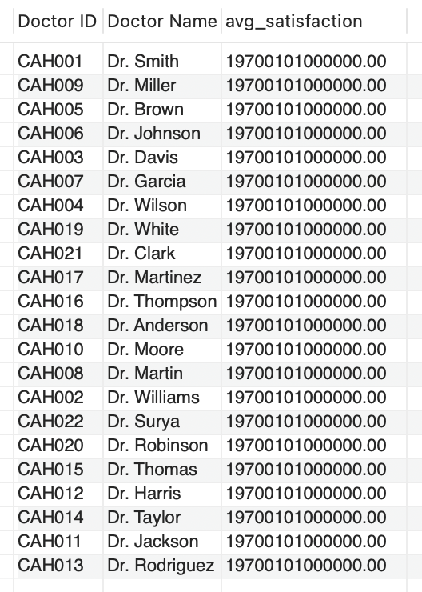

19. Find doctors who have treated patients from different races and calculate the diversity of their patient base. (SQL)
SELECT dp. Doctor_ID,dp. Doctor_Name,COUNT(DISTINCT he.patient_race) AS race_diversity
FROM doctor_patients_data dp
JOIN hospital_data he ON dp.patient_id = he.patient_id
GROUP BY 1,2
HAVING race_diversity > 1
ORDER BY race_diversity DESC;
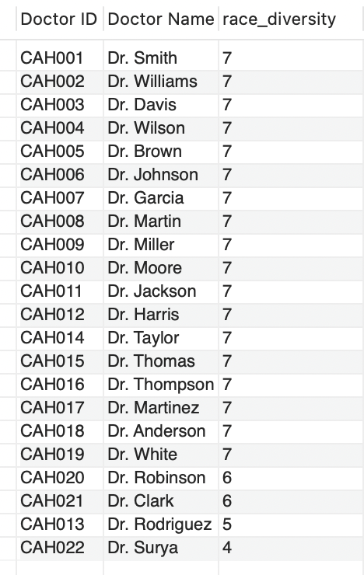
20. Calculate the ratio of total bills generated by male patients to female patients for each department. (SQL)
Select d.department_referral as department ,round(sum(case when h.patient_gender = "M" then d.total_bill else 0 end)/
sum(case when h.patient_gender = "F" then d.total_bill else 0 end),2) as gender_revenue_ratio
FROM doctor_patients_data d
JOIN hospital_data h ON d.patient_id = h.patient_id
group by d.department_referral
order by gender_revenue_ratio desc , department asc;
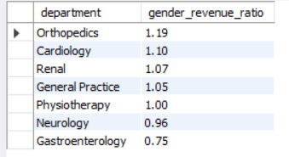
Q21.Update the patient satisfaction score for all patients who visited the "General Practice" department and had a waiting time of more than 30 minutes. Increase their satisfaction score by 2 points, but ensure that the satisfaction score does not exceed 10. (SQL)
UPDATE patient_visits
SET patient_sat_score = LEAST(patient_sat_score + 2, 10)
WHERE department_referral = 'General Practice'
AND patient_waittime > 30;

Subjective Questions

- What is the relation between patient wait time and satisfaction scores?
Ans.
Based on the current dataset, there doesn’t appear to be a strong or direct relationship between patient wait time and satisfaction scores. While wait time is generally considered an important factor in patient satisfaction, in this case, other elements seem to have a greater impact. These include the quality of treatment, the patient’s preferred doctor, accessibility, and overall experience. Therefore, even if the wait time is longer in some cases, patients may still report high satisfaction if other aspects of their visit meet or exceed expectations.
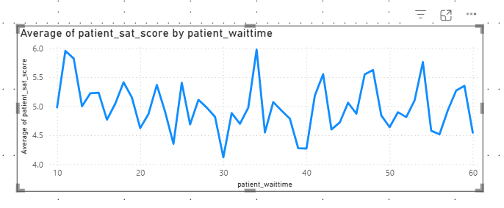
Q2.How do patient demographics affect the frequency of visits to different departments?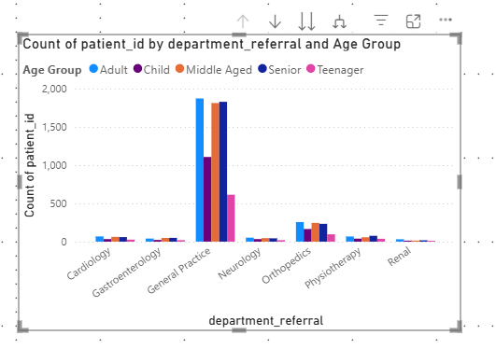
Insight
Demographics do not influence the number of visitors to various departments, as visit frequency primarily depends on the patient's health condition and the hospital's location. The demographic composition of different departments remains largely unaffected.
Result
The Stacked Column Chart confirms that demographic factors have minimal impact on overall visit counts across departments.
3.Is there a noticeable trend in the volume of patient visits throughout the year?
Explanation
- This analysis aims to uncover patterns in patient visit volumes throughout the year. A Line Chart with a Year-Month hierarchy helps visualize both annual and monthly fluctuations.
- The Count_of_Patients measure highlights variations in patient visit frequency over time.
- The drill-up and drill-down features allow for both a broad (yearly) and detailed (monthly) view, helping identify seasonal trends or irregular fluctuations in patient visits.

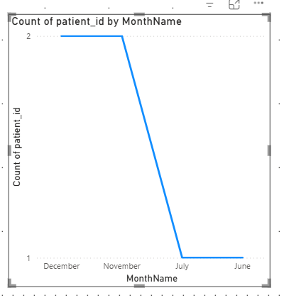
Insight
- In 2019, the total patient visits were 4,338, increasing to 4,878 in 2020, reflecting a 7.5% rise in visits.
- This growth suggests potential shifts in healthcare demand, possibly influenced by factors such as greater healthcare awareness, new medical services, or external events like the pandemic.
Result
- The analysis highlights a notable upward trend in patient visits in 2020 compared to 2019, indicating changing healthcare dynamics
4.Which age groups report the highest and lowest satisfaction scores?
Age Group Analysis
- Avg Patient satisfaction scores across different age groups range between 5.07 and 5.17.
Visualization
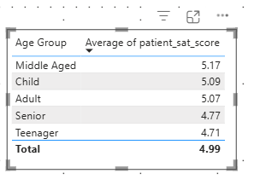

Insight
- Younger and middle-aged patients exhibit slightly higher satisfaction levels compared to older patients.
This indicates potential areas for service improvements tailored to the needs of senior patients, such as better accessibility, personalized care, or enhanced communication

5.Say someone outside of the hospital claims that there is racial or gender-based discrimination in the hospital, how will you identify whether the claim was right or not?
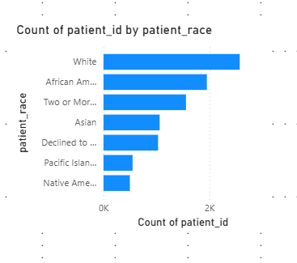
As shown in the above bar chart, patient visits are fairly distributed across different racial groups. While the majority of patients belong to the White racial group, the volume is closely followed by African American and Asian patients.
Based on the presented data, there appears to be no evident sign of racial discrimination, as the distribution suggests that patients from diverse racial backgrounds are being served proportionately.
6. The hospital management intends to offer discounts to patients. How should these offers/discounts be assigned to patients, on what basis, and why?
- A DAX formula was applied to determine discount eligibility based on the following conditions:
  - Total Bill ≥ 10,000
  - Satisfaction Score ≥ 6
- A DiscountEligibility column was created to classify patients as either "Eligible" or "Not Eligible."
- A Donut Chart was used to visualize the proportion of eligible vs. non-eligible patients.
Explanation:
- The hospital management aimed to offer discounts to patients who were high spenders and had high satisfaction scores.
- A DAX formula was used to categorize patients based on their total bill and satisfaction score, ensuring that only those meeting both criteria qualified for the discount.
The formula used is:
Discount Eligibility =
IF(
AND('Sheet1'[Total Bill] >= 10000, 'Sheet1'[Sat_Score] >= 6),
"Eligible",
"Not Eligible"
)
Visualisation:
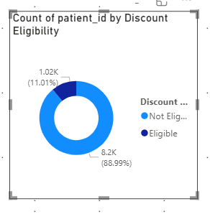
Insight:
- Out of 9,216 total patients, only 11.01% qualified for the discount, while the remaining 88.99% did not.
Result:
The Donut Chart visually highlights that a small proportion (11.01%) of patients meet the discount criteria, whereas the majority (88.89%) do not qualify

7.The hospital has a budget to hire 2-3 new doctors. They have asked for your suggestions on which departments they should hire.
The table visual displays department-wise doctor count along with average patient wait time. It is clearly visible that the General Practice department, despite having only 3 doctors, handles the highest volume of visits.
To manage this heavy workload and reduce patient wait times, it is recommended to hire 2–3 additional doctors in this department. This step will help improve operational efficiency, ensure timely consultations, and enhance the overall patient experience.
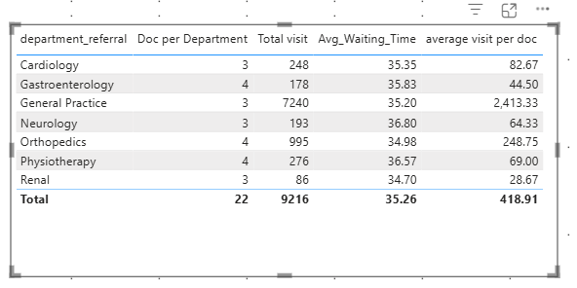
8.Is the hospital profitable? How will you determine the profitability?
Revenue = SUM(Doc_patients[Total Bill])
Expense = SUM(Doc_patients[Appointment Fees])
profit = DIVIDE([Revenue]-[Expense],[Revenue])
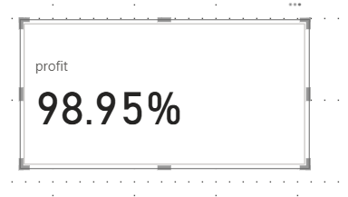
The hospital appears to be operating with a strong profit margin. Based on the available data, it can be inferred that the only significant operational cost factored into the revenue model is the doctor's appointment fee. This cost is excluded from the reported total revenue, meaning that the remaining portion essentially represents net profit.
9.Any Department for which the waiting time is oddly large?
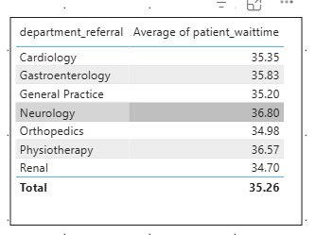
As observed in the above table visual, which summarizes department-wise total visits and average patient wait times, departments like General Practice and Orthopedics show an average wait time of approximately 35 minutes. Given their significantly high patient volumes, this level of wait time appears justified and within operational expectations.
10. Come up with strategies to provide discounts to the patients.
Ans.
Offering discounts in a hospital setting goes beyond just reducing costs—it plays a crucial role in enhancing patient trust, accessibility, and loyalty, while ensuring that hospital operations remain sustainable. Following are some effective and patient-centric discount strategies that can be implemented:
- First-Time Visit Discounts
Offering a small discount to first-time visitors encourages new patients to try the hospital’s services and helps in building long-term relationships.
- Referral-Based Discounts
Incentivizing patients to refer friends and family members can increase patient footfall through organic word-of-mouth marketing.
- Family or Group Discounts
Providing discounts for family health packages or group consultations encourages collective preventive care and brings multiple registrations at once.
- Follow-Up Visit Discounts
Reduced consultation fees for follow-up visits within a certain time frame improve care continuity and patient satisfaction.
- Senior Citizen Discounts
Special pricing for elderly patients helps address their frequent healthcare needs while reinforcing the hospital’s commitment to inclusive care.
- Subscription Plans
Hospitals can introduce prepaid wallets or monthly/yearly subscription models where patients receive added value for upfront payments.
11.Say you need to align the doctors of the “General Practice” department to work in one of the two shifts, how will you identify what will these two shifts' timings be, and how will you divide the doctors in these two shifts? And also will this 2 shift policy be helpful for the hospital?
- Created a table visualization with Doctor Name and Department to display the list of doctors and their respective departments.
- Used DAX to assign doctors to two shifts:
  - 8:00 AM - 2:00 PM
  - 2:00 PM - 8:00 PM
- Applied conditional formatting to highlight the General Practice department for better visibility.

Explanation:
The DAX formula used to assign doctors to shifts is as follows:
Shift =
IF(
MOD(RANKX(ALL('Sheet1'),'Sheet1'[Doctor Name], ,ASC),2) = 0,
"8:00 AM - 2:00 PM",
"2:00 PM - 8:00 PM"
)
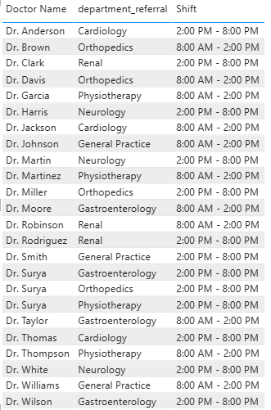
The formula used also ranks doctors by name and alternates shift assignments using the MOD function. This ensures a balanced distribution of doctors across shifts, based on patient volume.
In this case:
- Dr. Johnson and Dr. Williams were assigned to the morning shift (8:00 AM - 2:00 PM) due to higher patient traffic.
- Dr. Smith was assigned to the evening shift (2:00 PM - 8:00 PM) to manage lower patient volume during those hours.
12.What do you understand by PowerBI gateway? What are its use cases?
Ans.
Power BI Gateway is a bridge that enables secure communication between on-premises data sources and cloud-based Microsoft services like Power BI, Power Apps. It allows organizations to connect and refresh on-prem data in Power BI reports without uploading data to the cloud manually.
There are two types of gateways:
Standard (Enterprise) – Used by multiple users and services.
Personal Mode – Used by individual users, only for Power BI.

Key Use Cases

Scheduled Data Refresh
Automates the refresh of reports and dashboards using on-premises data like SQL Server, Oracle, or Excel files stored locally.
Live or Direct Query Connection
Enables real-time dashboards by allowing Power BI to directly query on-prem systems such as SQL Server or SSAS.
Power Platform Integration
Supports Power Apps and Power Automate to trigger actions or collect data involving on-prem systems.
13.How would you approach this problem, if the objective and subjective questions weren't given?
Steps for Data Analysis in Power BI:
- Import the Data:
Begin by importing the dataset into Power BI to initiate the analysis process.
- Use Power Query for Data Transformation:
Utilize Power Query to filter, merge, and shape the data to match the required structure, ensuring it’s ready for analysis.
- Clean the Data:
Address any inconsistencies, handle missing values, correct data types, and standardize formats across the dataset to ensure accuracy and consistency in the analysis.
- Identify Key Performance Indicators (KPIs):
Identify the most relevant KPIs based on the objectives of the analysis, focusing on metrics that will provide meaningful insights for decision-making.
- Analyze Each KPI:
Dive deep into each KPI by exploring trends, relationships, and patterns to uncover insights that align with the analysis goals.
- Create Reports and Dashboards:
Develop comprehensive reports and dashboards using various visualizations like bar charts, line graphs, and tables to effectively communicate findings.
- Add Interactive Slicers and Filters:
Enhance the reports by adding interactive slicers and filters, allowing users to dynamically explore the data based on different dimensions for more personalized analysis.
Review and Finalize the Report:
Review the final report for accuracy, clarity, and relevance. Provide actionable recommendations based on the insights gathered during the analysis process to support informed decision-making.
14.Can you analyze and write the type of relationship between the doctor id and department, is it one-to-one?
- Unique Doctor Assignment:
Each doctor is assigned to one department, ensuring clarity in the structure of the organization.
- Multiple Doctors per Department:
A single department can have multiple doctors, which allows for specialization within that department.
- Data Modeling:
In a relational database, you can set up a foreign key on the doctor table that references the department table, linking each doctor to their respective department.
- One-to-Many Relationship:
When analyzing the relationship, think of the department as the “one” side and the doctors as the “many” side. Each department can have many doctors, but each doctor is limited to only one department.
- Querying and Reporting:
In reports or queries, you can aggregate data by department (e.g., count of doctors per department) or drill down to see the details for each individual doctor.
- Data Integrity:
Enforcing this relationship helps maintain data integrity, ensuring that each doctor is assigned to only one department, preventing errors in reporting or data analysis.
- Department-Level Metrics:
Departments can be analyzed independently (e.g., department-wise doctor count) or combined with other metrics like patient load, performance, or financials.

